**Experiment 2:-**Design an LED Chaser

**Circuit Diagram:-** 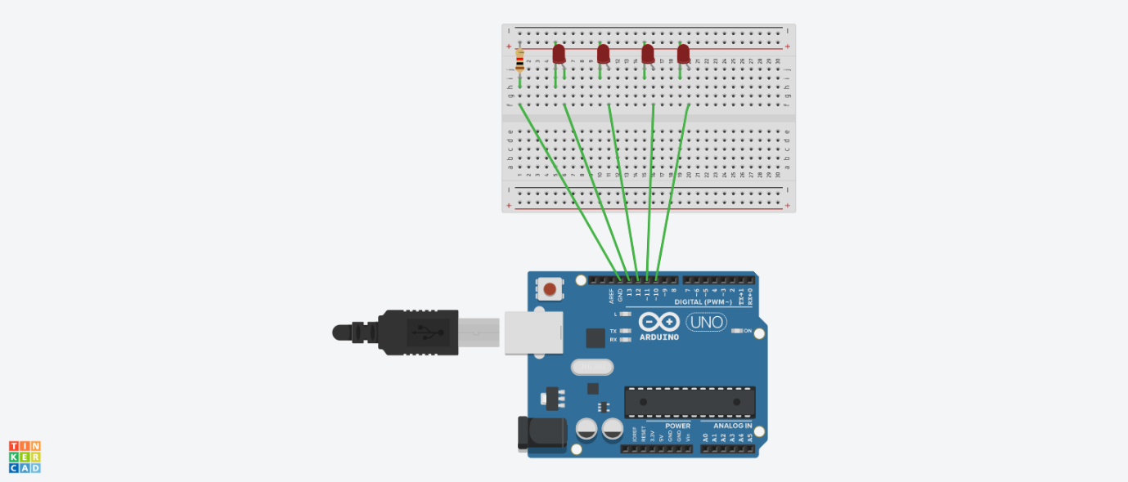

**Theory:-**

**Concept Used:-**

* The arduino board can supply a power of 5v as digital output signals through the 14 pins present in it.
* The GND pin acts as ground.
* In the breadboard, the two rows present at the top and bottom each, are connected with each other in series and the columns present in between are connected in a set of 5 each. The connection pattern is shown below:
* 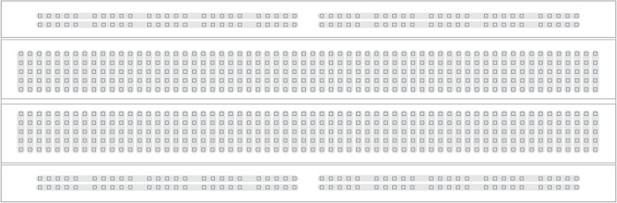
* In series crcuit voltage gets divided and in parallel circuit current gets divided.
* KCL:-Total current flowing through a junction is equal to current flowing out of the junction.
* Ohm’s Law:-Ohm’s law states that the current through a conductor is directly proportional to the voltage across the two points provided that the physical conditions such as temperature remains constant.

V=IR

**Learning and Observation:-**

**Learning:-**

* Learned how to make a parallel circuit connection using arduino board and breadboard.
* Learned how to make pattern of different types using LED bulbs.

**Observations:-**

* While doing this experiment I observed that a chain like pattern is formed and this replicates the code we wrote for arduino

**Problems and Troubleshooting:-**

* The LEDs were not working properly so I had to replace them with new ones.
* The arduino board was not working.This was because the correct port is not selected.
* The required pattern was not replicated because of wrong code to have to modify the code.

**Precautions:-**

* Check if the wires are inserted properly.
* Pins of led should be checked before forming the circuit.
* We should take care that the circuit is closed.

**Learning Outcomes:-**

* Learned how to connect different hardware with arduino to form a parallel series.
* Gained skill of making different kind of patterns using LEDs and arduino board.